CS 306 Project Step 4

Admin panel: Anıl Ozan Ayhan

Beril Şengezen

We created an admin panel in which data can be inserted to several of our tables. It has a navbar at the top that redirects to whichever page the admin wants to go to. We can also delete users using their id from this page. The page has a users table at the end of it so the admin can easily see the most important table without leaving the admin panel. We also added a background for better visuals.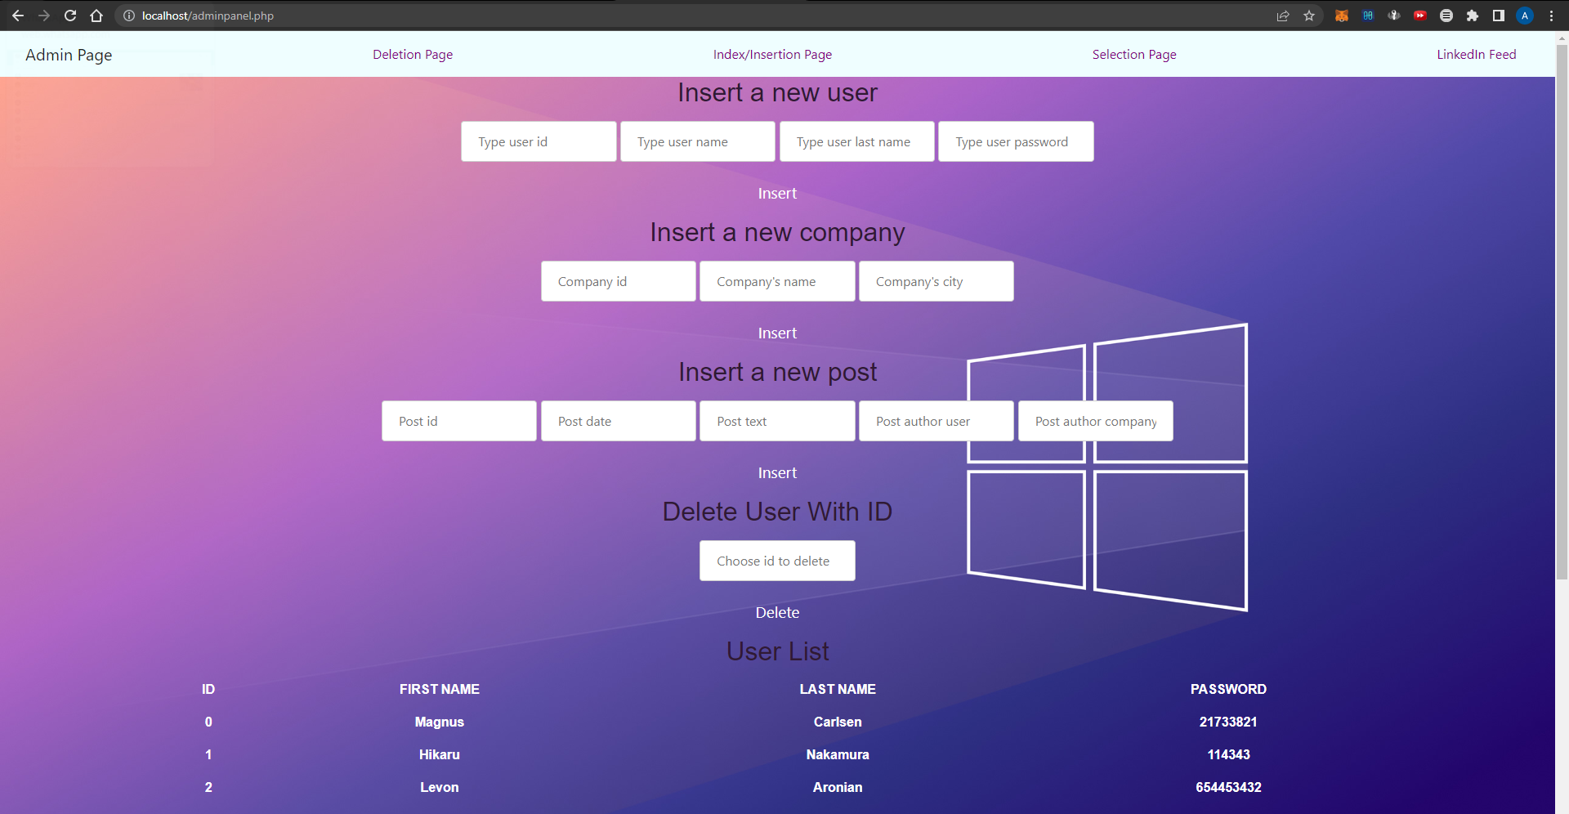

The forms are all functional and all of them can be used to insert data. The links in navbar lead to our pages we created in step 3.

Those are insert, delete, and select.

User panel:

Since we are making a LinkedIn styled database application, we added a homepage like LinkedIn’s feed that showcases posts and connections people made. The page links a few databases together. For instance, when printing the posts, it takes the id of poster and post content (text) from ‘post’ database. It checks if that id belongs to a user or a company. If it is a user, it links this id number with the users page and prints out the name of user with that id. If it’s a company, it does the same but with company database. It also takes 2 inputs, user1 and user2 from connections database, finds those id’s in users or company and prints out a message saying they connected.

Going forward, we will connect and use all the databases in the user panel, add a login page to implement better security, and much more.